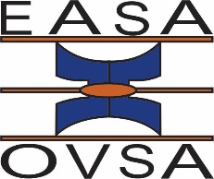

**EASA RESEARCH MEDAL: 2025**

**CALL FOR NOMINATIONS**

**Closing date for nominations: 11 September 2025**

Please email a scanned version of the CV, motivation and nomination form to [johnnie@akademia.ac.za](mailto:johnnie@akademia.ac.za)

**RECIPIENT**

The medal is awarded to an individual who has attained outstanding achievements in the field of educational research over a period of at least 10 years and who has not previously received this award. The recipient must be a member of EASA.

**CRITERIA FOR AWARD**

Outstanding achievements in educational research demonstrated by consistent publications in academic journals as well as book publications with international impact.

Leadership and development of education research demonstrated by two or more of the following:

* Successful supervision of post-graduate students
* Editorship of academic journal(s)
* Leadership of national/international research associations
* Successful completion of funded research projects

**PROCEDURE**

A candidate may be nominated by an institution, the Executive Committee, or any individual member of EASA for consideration by the Executive Committee of EASA. Nomination must be accompanied by a **comprehensive curriculum vitae and an extensive motivation** to indicate that a person meets the criteria set out.

**OCCASION FOR AWARD**

The award will be awarded at the 2026 EASA Conference (11-14 January) at the Protea Hotel, Stellenbosch. The Chairperson of EASA is to present the award. The recipient of the medal as well as the person who nominated the recipient must be present at this function.

**AWARD: EASA RESEARCH MEDAL**

A medal inscribed with the name of the receiver, the date and the name of the Association (EASA).

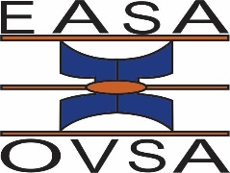

**NOMINATION FORM (Research Medal)**

Name of **nominee**:

Office address of **nominee**:

🕿

**Email**

**Proposer**:

Office address of **proposer**:

🕿

**Email**

Signature of **proposer**:

Date:

**Seconder**:

Office address of **seconder**:

🕿

**Email**

Signature of **seconder**:

Date:

**Nominee**

I declare that I have taken note of the criteria and procedures and accept the nomination for the EASA Research Medal.

Signature of **nominee**:

Date: